Rural Canada
A Socio-Economic Analysis

Matthew S. Watters – May 2014

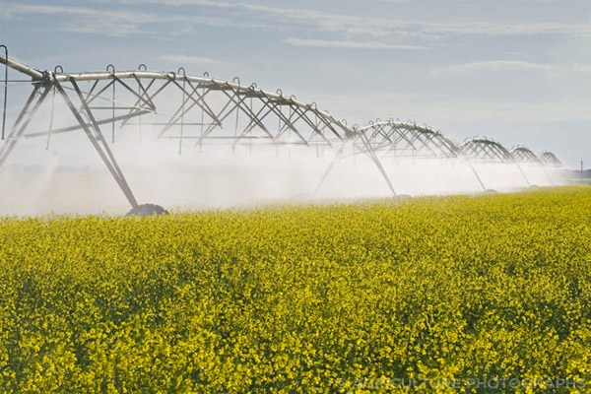

Table of Contents
Introduction 3
Canadian Demographics 3
Ontario Demographics 4
Canada’s Rural Economy 6
Ontario’s Rural Economy 6
Agriculture in Canada 7
Agriculture in Ontario 8
Forestry In Canada 9
Conclusion 10
Appendix A : Ontario Farms 11

Introduction

This report focuses on the changing socioeconomic dynamics that exist within Canadian rural communities. These changes are not constant across Canada’s expansive geographic landscape, and tend to vary highly by region, especially provincially. Using data from both the National level and from Ontario, this report highlights how a widening of the rural/urban divide disproportionately impacts Canada’s rural economies, and how this divide has impacted rural areas in Ontario specifically.

Canadian Demographics

The percentage of the Canadian population living in a rural area was 81 per cent when Canada undertook its first national census. This “urban/rural” split has completely inverted, and in 2011, only 19 percent of Canadians lived in a rural area. A significant portion of this inversion can be explained by the growth of Canadian cities, and the economic benefits derived by clustering labour and capital in urban areas. What is troubling is that this trend has continued and between 1961 and 2011, the percentage of Canadians living in rural areas dropped by 11 percent (30 per cent in 1961 to 19 per cent in 2011).

Figure 1: Percentage of Canadians Living in Rural Areas 1961 -2011

Source: Statistics Canada, 2011 Census of Population.

Last Modified: May 1, 2014

Taking a deeper look at this trend reveals not only a decrease in the percentage of Canadians living in rural areas, but also, a net decrease in the overall rural population. As the Canadian population increased by 6,179,832 between 1991 and 2011 Canada’s rural population decreased by 60,570 people.

Table 1: Net Changes in Urban/Rural Populations 1991-2011

Year | Canadian Population | Urban Population | Rural Population
1991 | 27,296,856 | 20,906,872 | 6,389,984
2011 | 33,476,688 | 27,147,274 | 6,329,414
Net Change | 6,179,832 | 6,240,402 | -60,570

Source: Statistics Canada, 2011 Census of Population.
Last Modified: May 1, 2014

Ontario Demographics

Ontario’s demographics mirror the national trend of increased urbanization, and an overall net decrease in rural residency starting in 1991, however, having started from a lower rural rate in 1961 (23 per cent), Ontario’s percentage of residents living in a rural area has plummeted to 14 per cent in 2011, 5 per cent lower than the national rate.

Figure 2: Percentage of Ontario Residents Living in Rural Areas 1961 -2011

Source: Statistics Canada, 2011 Census of Population.
Last Modified: May 1, 2014

As with the national trend Ontario has experienced a net loss in rural population, which represents approximately 25,000 people over the 20-year period 1991-2011. During this same period Ontario’s overall population grew by approximately 2.7 million people. An important question arises: How does the national and provincial trend of rural flight impact the rural economies and way of life for residents of Canada’s rural areas?

Table 2: Net Changes in Ontario’s Urban/Rural Populations 1991-2011

Year | Ontario Population | Urban Population | Rural Population
1991 | 10,084,885 | 8,253,842 | 1,831,043
2011 | 12,851,821 | 11,045,785 | 1,806,036
Net Change | 2,766,936 | 2,791,943 | -25,007
Source: Statistics Canada, 2011 Census of Population.

Last Modified: May 2, 2014

Canada’s Rural Economy

The major economic sectors in Canada’s rural economy are Agriculture, Forestry, Fishing, Mining, Quarrying and Oil and Gas. Statistics Canada aggregates these sectors except for Agriculture.

Canada’s employment figures grew steadily during the nearly 30 year period from 1984 until 2013, increasing by approximately 8 million employed persons across all industries. This does not accurately portray what happened in the rural economy. Canada has lost approximately 150,000 employed workers in the Agriculture sector over the past 30 years. This has partially been offset by increases in the remaining rural sectors, however this is also misleading as the majority of those jobs have been added in the oil and gas sector.

North American Industry Classification System (NAICS) | 1984 | 1994 | 2004 | 2013
Total employed, all industries | 135,625.7 | 156,733.5 | 191,119.8 | 212,755.7
Agriculture | 5,269.4 | 5,247.6 | 3,945 | 3,778.3
Forestry, fishing, mining, quarrying, oil and gas) | 3,769.6 | 3,424 | 3,449.4 | 4,405.8
Table 3: Canadian Employment vs. Rural Dominant Economic Sectors 1984-2013 (000’s)

Source: CANSIM Table 282-00881, 3, 5, 9: Labour force survey estimates (LFS), employment by North American Industry Classification System (NAICS), seasonally adjusted and unadjusted

Last Modified: May2, 2014

Ontario’s Rural Economy

The state of Ontario’s rural economy is far worse off than the national figures suggest.
As Table 4 indicates, Ontario has lost a significant number of jobs in both the Agriculture sector and the remaining sectors that have been aggregated. Ontario has lost approximately 50,000 employees across the major rural sectors, while adding nearly 300,000 thousand jobs across all sectors. This dichotomy has helped urban centres in Ontario prosper at the expense of the many rural Ontario economies

The numbers are clear, rural economic sectors have been in decline in Canada for the past 30 years, and Ontario is the province that has been disproportionately impacted by this decline.

Table 4: Ontario Employment vs. Rural Dominant Economic Sectors 1984-2013 (000’s)
North American Industry Classification System (NAICS) | 1984 | 1994 | 2004 | 2013
Total employed, all industries | 52,937.5 | 60,157.3 | 75,699.8 | 82,552.7
Agriculture | 1,368.4 | 1,338 | 962.9 | 1,040.8
Forestry, fishing, mining, quarrying, oil and gas) | 686.1 | 530.3 | 411.6 | 460

Source: CANSIM Table 282-00881, 3, 5, 9: Labour force survey estimates (LFS), employment by North American Industry Classification System (NAICS), seasonally adjusted and unadjusted

Last Modified: May 3, 2014

Agriculture in Canada

Agriculture accounted for approximately 58 per cent of Canada’s rural economy in 1984, however by 2013 this figure dropped to approximately 45 per cent. This is evidenced by a dramatic drop in the number of census farms between 1996 and 2011, where nationally there was a loss of 70, 818 census farms.

Source: Statistics Canada, Census of Agriculture. Last Modified May 5, 2014
Perhaps more disturbing is the loss of agricultural acreage over this same period. Canada lost approximately 800,000 acres of agricultural land during a 15-year period from 1996 to 2011. This represents a nearly 5 per cent loss of all agricultural land.

Source: Statistics Canada, Census of Agriculture.
Last Modified: May 4th,2014

Agriculture in Ontario

Ontario lost 15, 570 census farms between 1996 and 2011, which represents approximately 23 percent of all Ontario farms. Ontario lost nearly 8.7 percent of its agricultural acreage during this same period.

Source: Statistics Canada, Census of Agriculture.
Last Modified: May 4th,2014

Source: Statistics Canada, Census of Agriculture.
Last Modified: May 4th,2014

Forestry In Canada

The Canadian Forestry Industry has also been hit with massive job loss and economic decline over the past 25 years. In 1990 there were 336, 600 direct jobs attributed to the industry. By 2012 this number had diminished to 235,900 representing a loss nearly 30 percent of all Forestry jobs in Canada.

The Ontario Forestry industry lost 29,222 jobs between 1990 and 2012, representing a staggering 43 percent of the size of the industry in 1990.

Source: Natural Resource Canada

Last Modified, May 5th 2014.

Conclusion

Canada has experienced a significant loss in rural populations and massive job loss in key rural economic sectors over the past 3o years. Ontario has taken a substantial and disproportional amount of these losses. With the growth of Canada’s urban centres and these rural losses mounting, a few key questions arise: How long can Canada sustain this rural degradation? How is policy impacting this degradation? And finally, how has the environmental movement used conservation policy to speed the trend of rural clearance over the past 30 years?

Appendix A : Ontario Farms

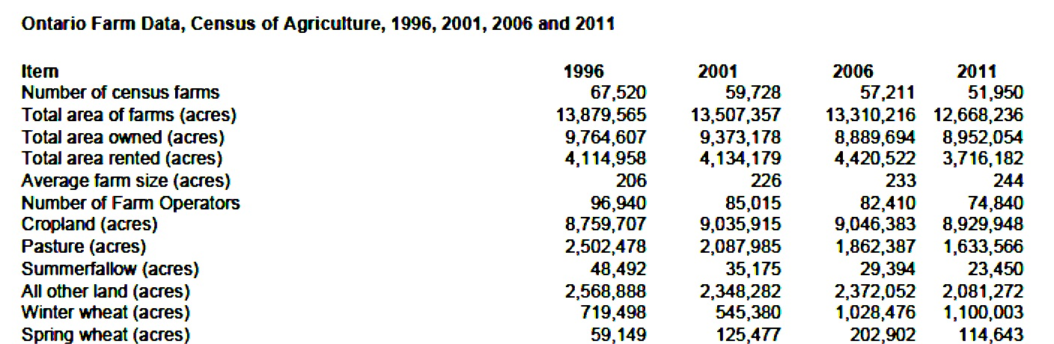

Based on computations from Table 3.
Natural Resource Canada: . http://cfs.nrcan.gc.ca/statsprofile/economicimpact/on. Accessed on May 2, 2014.

